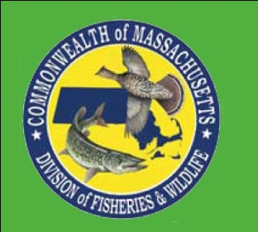
Professional Development Workshop

Growing Up WILD: Exploring Nature with Young Children is an early childhood education activity guide that builds on children’s sense of wonder about nature and invites them to explore wildlife and the world around them. Through a wide range of activities and experiences, it provides a foundation for developing positive impressions about nature while also building lifelong social and cognitive skills. Workshop participants will receive a copy of the guide and certificate of completion.

Growing Up WILD’s activity guide:
 Is written for early childhood educators of children ages 3-7.
Features 27 field-tested, hands-on, nature-based activities in a full-color 11”x17’’ activity guide.
Includes crafts, art projects, music, conservation activities, reading and math connections and much
more.
Involves social, emotional, physical, language, and cognitive domains to help foster learning and
development in all areas.
Supports developmentally appropriate practice allowing children to learn at levels that are
individually, socially, and culturally appropriate.
Is correlated to the National Association for the Education of Young Children (NAEYC) Standards and
the Head Start Domains.

Get Growing Up WILD:

Date: Saturday March 3, 2012 Time: 9:00-3:30
Location: MA Audubon’s Pleasant Valley Sanctuary, 472 West Mountain Road, Lenox
Hosted by: MA Audubon & MA Wildlife

Workshop fee: $30/ person (pre-registration & payment required)
To register: Contact Gayle Tardif-Raser, gtraser@massaudubon.org, (413) 637-0320. Registration deadline February 20, 2012
Please: wear comfortable clothes (dress in layers) & shoes for outdoor activities
bring a brown bag lunch & mug
Ages 3-7

